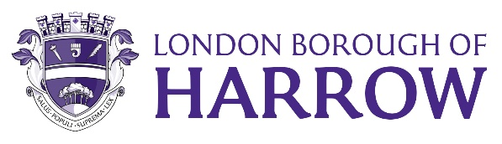

| Report for: | Governance, Audit,Risk Management andStandards Committee |
| --- | --- |
| Date of Meeting: | 29 November 2023 |
| Subject: | Annual Complaints report and update on complaints against Members 2022/23 |
| Responsible Officer: | Jessica Farmer  Interim Director of Legal & Governance and Monitoring Officer |
| Exempt: | No |
| Wards affected: | All |
| Enclosures: | Appendix A – Corporate Complaints policy  Appendix B – Annual review letter  from Local Government and Social  Care Ombudsman for year ending  31/3/23 |

| Section 1 – Summary and Recommendations |
| --- |
| 1.1 This report is an overview of complaints received throughout 2022-23 and complaints against councillors for this period. It will identify themes where work is ongoing to improve the Customer Experience lessons learned that have helped to improve Council services. The report updates the Committee and summarises data in a number of areas.  **1.2 Recommendations:**  The Committee is requested to note the information in the report. |

## Section 2 – Report

**2.1 Background**

**Customer complaints**

In July 2022 Cabinet approved an action plan to improve the customer experience. As part of this programme of work the Corporate Complaints policy was reviewed and adopted by Cabinet in June 2023. A copy of the policy is attached to this report as Appendix A

Most Council services run well, and any issues are resolved locally without any further action. If the citizen remains unhappy then they can make a formal complaint.

The Council has a two stage complaints process. A complaint will be reviewed with a response due within fifteen working days under stage I and if dissatisfied with the outcome the complainant can request that it moves to stage II. A more senior officer will review the complaint and initial response before replying within twenty working days. The Council’s process ends at this point and any further appeal may be made to the Local Government & Social Care Ombudsman.

The Local Government and Social Care Ombudsman investigates individual complaints about councils and help to make sure these organisations are accountable to their service users, by ensuring they put things right if things have gone wrong. The LGSCO do not investigate a complaint until the organisation concerned has been given the chance to respond.

Each year the Local Government & Social Care Ombudsman produce an annual report outlining the complaints received about a Local Authority. The annual Harrow report for 2022-23 is attached to this report as Appendix B

Complaints data is captured by individual services which is shared with the Corporate Complaints officer on a quarterly basis.

**2.2 Complaints about elected members**

It is important that members have an overview of complaints received against elected members and any trends. This report will enable the council to discharge its duty to promote and maintain high standards of conduct for Members; review the application of the Code of Conduct for Members’; and maintain an overview on ethical standards in general across the authority.

**2.3 Corporate complaints 2022/2023**

This report sets out performance of complaint handling at the London Borough of Harrow for the period 1 April 2022 to 31 March 2023 and focuses on the nature of complaints and the learning they provide to inform the future approach to service improvement.

Complaints concerning Adult Social Care (ASC) and Children’s Social Care are governed by separate statutory complaint procedures.

The Council welcomes customer feedback, to help us to identify and address problems for customers, so to improve our services. This report demonstrates our transparency about the feedback we have received and what we’ve done to put things right.

**2.4 Summary of corporate complaints**

The London Borough of Harrow has a clear, corporate commitment to improving the customer experience. The Customer Commitments, launched and approved at Cabinet in June 2023, sets out what residents should expect from staff, including service standards in relation to complaints. The aim is for the organisation to be sensitive to customer needs, prioritise communication and provide clear and current information.

The Corporate Complaints officer and Head of Customer Contact & Engagement monitor the numbers of complaints received and the quality and timeliness of responses. The team works closely with service areas to ensure that corrective actions are put in place and that learning from complaints is built into service design.

The Council handled over 5,800,000 enquiries in 2022/23 across its communication channels and were involved in millions of service interactions including bin collections and library visits.

In total, there were 2,313 corporate complaints received in 2022/23 of which 128 were escalated to stage II. There is no corporate complaints IT system so limited information is kept on timescales however where this data is available it shows that 81% of complaints were responded to within timescale.

The Local Government & Social Care Ombudsman (LGSCO) received 95 complaints last year for Harrow and investigated twenty-three (24%) of these. Further details are outlined later in the report.

**2.5 Directorate Summaries**

Each council department reviews the complaints and compliments it receives and data is compiled on a quarterly basis. This enables services to identify if there are any trends in the types of complaint being made or the service requests that complaints are being made about. As a result, changes can be made to services and how they are provided.

The next section of this report details comments from Services on actions they have taken to prevent, improve or change as a result of the feedback received in previous years.

**2.6 Resources Directorate**

The table below shows the number of complaints received for Corporate Resources



Of the 500 stage I complaints received within Resources, 52% were in relation to Concessionary Travel. The complaints are where the resident has been unsuccessful in their application and is unhappy with the decision. The Council has a set of criteria as to who is eligible for a Blue Badge and physical assessments are carried out where required to ensure that these are approved where appropriate.

Council Tax & Benefits accounted for 40% of the complaints within Resources. The most common complaint relates to summons costs applied after a final notice is applied for non-payment however there is no overarching theme of discontent.

**2.7 Place Directorate**

The table below shows the number of complaints received for the Place Directorate



Over 70% of the complaints within the Place directorate are connected to Environmental Services. These fall under three common categories:

Missed Bins – where the resident remains dissatisfied with their collection. The Council has upgraded the in-cab technology and is rolling that the use of the system across all refuse teams. This will make it easier for residents to report and escalate missed bins and for the service to identify patterns of non-collection. The service already investigating addresses where multiple missed collections occur to understand the reasons why and to implement procedures to improve.

Fly Tipping & Street Cleaning – where residents are unhappy with the cleanliness of their road. The Council runs a responsive cleaning team that removes fly tips within 48 hours. Enforcement teams will investigate certain fly tips with a view to identify the perpetrator and arrange for removal afterwards. The Council has recently introduced a number of mobile CC-TV cameras to help identify and prosecute fly tippers in areas where offences are high.

Road Maintenance – where residents are unhappy with the condition of the pavement or road where they live. The Council has since taken a targeted approach to resurfacing roads in greatest need based upon condition surveys.

Housing accounts for 22% of complaints across the Place Directorate. The most common themes include:

Repairs

* Mould / damp
* Fence repair
* Leaks
* Roof/Ceiling repair

Resident Services

* Parking
* Neighbour disputes, ASB & Fly tipping
* Rent arrears

Housing Needs & Homelessness

* Accommodation
* Rehousing
* Locata

The Housing Service introduced a number of initiatives to improve complaint management:

Reviewed complaints policy in line with the Council’s updated policy and the requirements of the Housing Ombudsman Complaint Handling Code

Set up a resident panel early this year to review customer feedback

Every Monday weekly performance is published internally, and reminders are sent in advance to encourage colleagues to comply with timescales.

A dedicated officer is appointed to manage and respond to multiple issues raised by a resident.

Greater analysis to understand how Damp and Mould issues are handled

Engaged with House Mark to submit monthly data in order to help benchmark with other social housing providers.

Developed a complaints satisfaction survey to capture feedback on complaint handling.

**2.8 People Directorate**

The table below shows the number of complaints received for the People Directorate



There were 69 Stage I complaints within Childrens’ Services and these fell into two categories:

Education and SEN accounted for 26 complaints where the complainant was unhappy with the education provision allocated to their child.

Childrens Social Care accounted for 43 complaints where the complainant was dissatisfied with the professional judgement and decision made in assessments or reports. In context, there were 4,549 children open to the service throughout 2022/23 with 3,018 referrals made.

There were 116 stage I complaints made against Adult Social Care. This is in context of 9,599 requests for a service being made with 4,220 adults receiving long term care alongside 1,698 receiving short term care.

The predominant theme is the charge for care. This includes concerns with the financial assessment process and outcome, information regarding paying for care, invoices and financial advice.

Although response times are longer than those in other services, it should be mentioned that the issues tend to be more complex, requiring investigation usually by social workers with already high case loads. During this time, residents are updated with progress.

The learning from complaints includes

* Further awareness of staff to complete reviews on the IT system in a timely manner
* Consultation with care leavers regarding their pathway plan
* Greater adherence to statutory timescales.
* A refresh of complaints handling and feedback processes so that there is a robust and effective system in place for ensuring timely and quality responses and for monitoring purposes.
* Better clarity on charging for care provision

**2.9 Local Government & Social Care Ombudsman (LGSCO)**

The LGSCO received 95 complaints last year and investigated twenty-three (24%) of these. Of the 23 investigated, seventeen (74%) of these were upheld. This compares to an uphold rate of 77% against similar-sized Local Authorities.

In all cases the Council complied with the LGSCO recommendations.

In two instances (12%) the Council had provided a satisfactory remedy before the complaint reached the Ombudsman. Although this is a higher rate than all but one of our NW neighbours, the national average was 15% highlighting that there is further work to be done to resolve issues as soon as possible.

The table below shows the service areas from where the LGSCO received complaints.

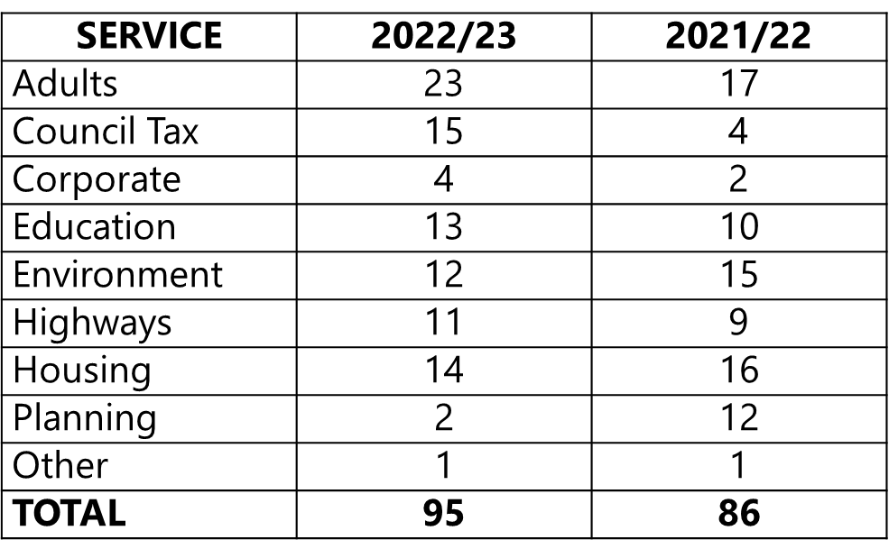

The Ombudsman has been more selective about the complaints they look at in detail due to resource constraints, so have prioritised those where it is in the public interest to investigate.

It has meant that changes in uphold rates this year has increased as they are less likely to carry out investigations on ‘borderline’ issues, so are naturally finding a higher proportion of fault overall. There has been an industry increase from 71% to 77%. Harrow saw a slight decrease from last year’s uphold rate of 78% which is pleasing considering the bar was raised.

Of the 72 complaints rejected by the LGSCO,

* 30 were premature (had not followed the Council’s complaints process)
* 30 were closed after initial enquiries (usually because there is a separate process/tribunal to follow)
* 6 cases were rejected as no fault was evident (the complainant did not agree with the council’s decision)
* 3 complainants were redirected to the appropriate body by the LGSCO
* 3 cases were rejected due to insufficient information and no follow up from the complainant

The table below gives a perspective of the ratio of complaints received that end up with the LGSCO.

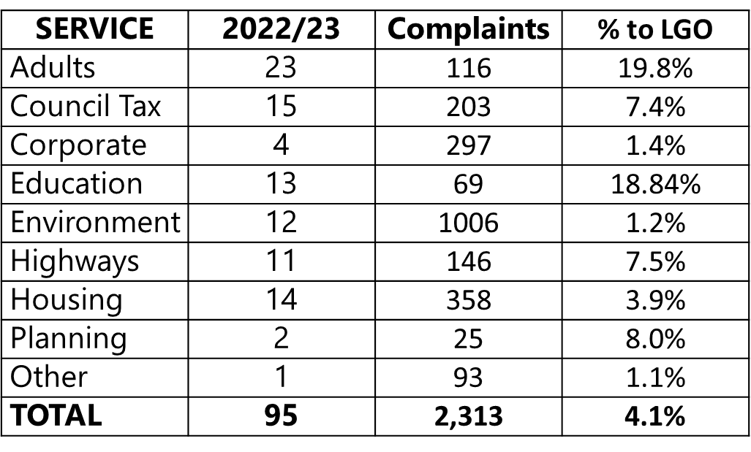

When filtered by service, there is no pattern or trends in the type of complaint received by the LGSCO.

The Ombudsman did point out that there were occasions when the Council did not respond in a timely manner to the LGSCO which delayed their response and seven of the LGSCO recommendations were not completed within a timely manner. These issues have been addressed with the relevant services to prevent a further occurrence in the future and an escalation process is in place to highlight any potential delays.

In comparison to our North West London neighbours, Harrow performed well in the number of complaints being upheld after investigation by the LGSCO. The National Average was 77%

|  |  |  |  |  |  |
| --- | --- | --- | --- | --- | --- |
| . | Percentage (number) Upheld | Compliance with LGSCO recommendation | | Satisfactory remedy already provided by Council | |
| Hounslow | 86% (15) | 100% | 13% | |
| Harrow | 74% (17) | 100% | 12% | |
| Brent | 76% (22) | 100% | 41% | |
| Barnet | 78% (39) | 100% | 8% | |
| Hillingdon | 86% (24) | 100% | 8% | |

There were two cases where the Council had failed to correctly signpost complainants to the LGSCO at the end of the local complaints process. This issue has been addressed with the relevant service area to ensure that the correct templates are used so that all relevant information is shared with the customer.

The LGSCO annual letter can be found in Appendix B

**2.10 Conclusion - corporate complaints**

The Council strives to deliver high quality services to all residents and customers and welcome all feedback on our services and suggestions for improvement.

Staff work hard to understand the reasons for the complaints, and where a consistent theme or issue has been established, have taken action to prevent the poor service that triggered those complaints from being repeated.

The Corporate Complaints officer continues to review data on a monthly and quarterly basis to establish themes and trends. The Complaint co-ordinators network ensures that issues can be discussed and best practise shared.

Data relating to complaint responses is a flagship action and wider performance data is reported on a quarterly basis to Directors and Heads of Service to prompt reflection on what services need to do to improve, change or prevent a reoccurrence. Particular attention is focused on responding appropriately to complaints first time and reducing complaints being escalated to the higher stages.

This reporting has led to some constructive discussions with Senior Management, and as a result we have been able to take feedback and apply it across many areas of the complaints process.

The Customer Services team continue to provide training and support to Officers within the Council, with a strong focus on Customer Service ethos to ensure that a consistently high level of customer service is provided to our residents and service users.

**2.11 Complaints against Members 2022/2023**

Four complaints were dealt with during the period 1 April 2022 to 31 March 2023, this compares to five complaints for the previous year. Historically in years with elections there tend to be more complaints. One of the complaints the complainant did not provide any details. In one case the resident did not respond to further enquiries and in three cases no evidence was found of a breach.

In order to deal with each complaint the Monitoring Officer contacts the member who is subject to the complaint and consults the Independent Person. The Independent Persons are appointed by council and were recruited after a member interview panel.

Under the procedure for dealing with member the Monitoring Officer in consultation with the Independent Person is able to filter out complaints that:

• do not fall within the code of conduct;

• are considered to be frivolous or vexatious;

• are about events which took place more than 6 months’ prior to the receipt of the complaint by the Monitoring Officer, unless there are exceptional circumstances; and/ or

• do not merit further investigation on public interest grounds.

For the period April 2022-March 2023

|  |  |  |
| --- | --- | --- |
| **Complaint** | **Alleged Provisions of Code engaged / allegation made by the resident** | **Decision** |
| 1 | Not treating others with respect | No evidence found of a breach. |
| 2 | Not treating a resident with respect and not responding to correspondence | Councillors responded to the correspondence and  no evidence found of a breach. |
| 3 | Not treating a resident with respect | Resident did not respond to further inquiries |
| 4 | Calling in a planning application | No evidence found of a breach of the code of conduct. |

## 3.0 Legal Implications

Corporate complaints

Having an effective complaints management system is part of an effective corporate governance framework, allowing the Council to continuously review and improve its services in response to feedback.

Residents and service users who remain dissatisfied with council services, having followed the internal complaints process, have a right to complaint to the LGSCO or the Housing Ombudsman (for landlord related matters). These are independent bodies responsible for investigating complaints made against local authorities (and social landlords). Under the Local Government Act 1974, the LGSCO is responsible for investigating complaints against local authorities, investigating complaints about adult social care providers from people who arrange or fund their own adult social care and for providing advice and guidance on good administrative practice. It is responsible for making findings of maladministration and injustice.

The LGSCO has the power to make recommendations to a local authority following a complaint on how to improve its services and to put things right for the complainant. The recommendations are not mandatory and the local authority does not have to accept or follow them. Remedies recommended by the LGSCO can include an apology, financial compensation, a review of procedures, staff training, and reconsideration of a decision and payment of money where this should have been paid.

Case law has held that maladministration includes bias, neglect, inattention, delay, incompetence, ineptitude, perversity, turpitude and arbitrariness. Examples of maladministration include excessive or unreasonable delay, making misleading or inaccurate statements, failing to follow a specified procedure, failing to consult or liaise, failing to provide information when requested to do so, not keeping adequate records and failing to investigate or reply to a query from a member of the public. The LGSCO is concerned with the manner in which the decision was reached, as opposed to the actual decision.

The LGSCO has published guidance on good complaints handling and principles of good administrative practice. This guidance states that to ensure effective governance the statutory governance officers should be aware of and engaged with complaints and should intervene at the right time. Learning from complaints should be at the centre of the risk management framework and audit function. The principles for effective complaints handling include getting it right by complying with the law and policies, being customer focused, being open and accountable, acting fairly and proportionately, putting things right, including apologising and putting right injustice and seeking continuous improvement.

There are specific legal requirements for certain types of complaint, including children’s social care, adult social care, school admissions and transport, housing benefit and council tax, homelessness, standards and member conduct and parking and traffic offences. Some matters will be outside the complaints policy due to other statutory routes being available to complain about the decision or service.

Section 5 of the 1989 Local Government Act requires the Monitoring Officer to report maladministration or failure in relation to LGSCO complaints to members.

**3.1 Member complaints**

Under the Constitution the Governance, Audit, Risk Management and Standards Committee has the following powers and duties:

* Monitoring the operation of the Members’ Code of Conduct.

3.2 The Members’ Code of Conduct is set out in the constitution. The Council’s arrangements under which complaints about Member conduct are investigated and decided comply with the relevant provisions of the Localism Act 2011. All complaints are dealt with in consultation with one of the council’s Independent Persons that the council has to appoint under the Localism Act.

## 4.0 Financial Implications

There are no financial implications associated with this report.

## 5.0. Risk Management Implications

Risks included on corporate or directorate risk register? **YES**

“The Council provides a poor customer service” is included on the corporate risk register and rated at C3 (medium likelihood/moderate impact)

Separate risk register in place? **NO**

Are the relevant risks contained in the register are attached/summarised below? **NO**

The following key risks should be taken onto account when agreeing the recommendations in this report:

| **Risk Description** | **Mitigations** | **RAG Status** |
| --- | --- | --- |
| The Complaints policy is not adopted by staff. | * A separate guidance document has been created to inform staff * Complaints coordinators are in place across the Council and network meetings to share best practise is in place. * Officers can liaise with the senior staff within Customer Services for assistance | GREEN |
| The Complaints policy does not improve the customer experience | * There are baseline measurements to understand the current position * These will be measured throughout the year so that any necessary restorative actions can take place | GREEN |
| Customers are unaware of the complaints policy and cannot access it | * The policy is available on-line * A copy of the policy can be obtained upon request | GREEN |
| Customers do not understand the policy and/or find it confusing | * Council Officers are able to explain the policy * Google Translate can be used to translate the policy into another language | GREEN |

## 6.0 Equalities implications / Public Sector Equality Duty

6.1 This report is to provide an overview of complaints received to the Council throughout the year 2022/23

6.2 It is a breach of the Member Code of Conduct to discriminate against people on the grounds of any of the protected characteristics in the Equality Act. Members have been provided with training in the Code of Conduct this area. When dealing with complaints the Monitoring Officer consults the Member complained about and the Independent Person.

#### 7.0 Council Priorities

Dealing effectively with complaints assists the council with putting residents first.

1. A council that puts residents first
2. A borough that is clean and safe
3. A place where those in need are supported

## Section 3 - Statutory Officer Clearance

**Statutory Officer:**

Signed by the Chief Financial Officer : Sharon Daniels

**Date: 20.11.23**

**Statutory Officer:**

Signed by the Monitoring Officer : Jessica Farmer

**Date: 20.11.23**

## Mandatory Checks

### Ward Councillors notified: NO, as it impacts on all Wards

## Section 4 - Contact Details and Background Papers

**Contact:** Jonathan Milbourn

Assistant Director for Digital, Data & The Customer Experience

[Jonathan.milbourn@harrow.gov.uk](mailto:Jonathan.milbourn@harrow.gov.uk) : 020 8863 5611

**Background Papers**: NONE